

**Campus Meal Ordering System**

**Project Proposal**

**By *Team Foodie***

**Lab Group: TS3**

**Date: August 2020**

**Instructors:**

**Bo An**

**Leong Yin Yoke Junie**

**Qiu Wei**

**Wang Rundong**

# SCHOOL OF COMPUTER SCIENCE AND ENGINEERING

**NANYANG TECHNOLOGICAL UNIVERSITY**

**Contents**

Executive Summary 3

Statement of Problem 4

Objectives 4

Technical Approach 5

Needs of Customers 5

Target Specifications 5

Technology Consideration 6

System Architecture/Platform 6

Project Management 7

Deliverables 9

Budget 10

Communication and Coordination with Sponsor 11

Team Qualifications 11

References 13

Appendix A: Résumés of Team Members 14

Han Si Meng 14

He Yu Hao 15

Loh Yi Xuan Renice 16

Ma Xiao 17

Yeoh Jun Yi 18

**Executive Summary**

In light of the recent covid-19 pandemic, Singapore is becoming a ‘dabao’ nation. There is an increasing trend of consumers taking away their meals instead of dining in[1].

With the new mandates imposed by the government, while many food businesses have been forced to shut down, the remaining have started offering takeaway and delivery options [2]. As a result, the food delivery industry has been prospering [3]. Therefore, there is potential to expand on this industry to serve the needs of the students and staff, as well as food businesses in Nanyang Technological University.

The proposed project is aimed to improve the quality of life of students and staff by providing a variety of food options with time saving solutions. At the same time, the project also increases the exposure of various food businesses in and around Nanyang Technological University (NTU) through digitalization.

We are proposing to launch a food delivery/takeaway application to cater to students, staff and food owners in NTU. Users will be able to browse through the wide selection of participating merchants and will be able to place their order ahead of time with their desired pick-up or delivery time. In doing so, this will reduce waiting time between the consumers and merchants, and minimize physical contact amongst one another. The application will also include contactless payments. These align with post circuit breaker safe distancing measures [4].

This proposal outlines in more detail how we will do it.

**Statement of Problem**

Campus population is a unique social group with a schedule crammed with activities including classes, extracurricular activities, part-time jobs etc. Students and staff try their best to keep on schedule as well as save as much time as possible for personal growth, entertainment and restoration.

Dining is an indispensable part of life and should be conducted in a satisfactory manner. Canteens and food courts on campus are scattered around. During interviews with NTU students, multiple students complain that “The travel and especially queuing time are annoyingly and unnecessarily long. ” Moreover, despite the variety of the food each dining place offers, each and every individual has divided needs which cannot be amply catered for by the closest canteen to the hall or the classroom. Picture this, one could be craving for the salty-egg chicken at a canteen four bus stops away, however, the next class is in an hour. The travel and queuing time precludes the gratification of such a reasonable basic desire.

Food delivery apps serving the general public are becoming increasingly popular, however, the prices of the food coupled with delivery fees are prohibitive, especially to students. Therefore, the campus population are in desperate need of a food delivery app specifically designed for them which makes myriad foods more readily accessible while saving time and money in tandem, thus bringing a kind of felicity to the campus population that has yet been discovered.

**Objectives**

Thus we propose an online food ordering cum delivery aggregation app that will be able to fulfill customer’s demand for on demand food delivery whilst reducing the number of delivery drivers needed to cater densely populated areas. To achieve this we have several objectives in mind:

1. Provide customers with on demand food ordering at their fingertips
2. Aggregate delivery orders for customers in close proximity
3. Optimize the delivery driver to customer ratio

The product will resemble other competing apps that provide online ordering/delivery services. The app should be recognisable to the average customer to reduce learning time for the user.

By aggregating delivery orders from many customers of similar locations a single delivery driver can serve more customers per trip and will especially benefit customers that live in more densely populated areas and are inherently compatible with campuses. By virtue of aggregating delivery orders, delivery drivers will be able to earn more per trip and will free up other drivers to service other areas thus the app will be able to cater to a wider geographical area with a limited number of drivers. By increasing the number of customers a driver can service per trip will also make trips that are further more feasible to cater to thus increasing the number of options a customer will have

**Technical Approach**

Our app will be running on the mobile phone platform since it is most convenient to people. To offer better user experience, our app would have user-friendly interfaces and well designed algorithms running on the backend. System design and software design would both be considered and explained in detail as follows.

**Customer Needs**

1. User-friendly: the app should be easy to install and intuitive to use.
2. Portability: the app should be functional regardless of the user’s location.
3. Accuracy: the order status should be recorded accurately.
4. Responsivity: the app should take minimum time to take response when a user is requesting for services.
5. Stability: the app should function stably under expected conditions.
6. Privacy: the user privacy should be well protected, data gathered should be transparent to the user.
7. Scalability: the app should scale as the number of users increases.

**Target Specifications**

1. User-friendly: All the functionalities will be integrated into a single app that does not require other plugins to be downloaded manually by users. We will also make instructions clear and concise so that users know how to use it easily.
2. Portability: As long as the user has access to the Internet and Google services, the app would be available, regardless of location.
3. Accuracy: The database will be accurately updated and the order status will be accurately shown on the interface.
4. Responsivity: We would make seamless integration of frontend and backend as well as optimize the backend algorithms to ensure short response time.
5. Stability: We would offload all computation to the backend on reliable servers and ensure the uptime of services.
6. Privacy: We would save all the user data in a reliable database supported with encryption, no payment data will be held and we will prevent unnecessary disclosures to any third parties.
7. Scalability: We would use a backend server built on Google infrastructure that will scale seamlessly.

**Technology Consideration**

| Framework/ Platform | Function | Consideration |
| --- | --- | --- |
| Flutter | Frontend | 1. Well-documented: it is easy to get to work with 2. Cross platform: it can work on both android and ios 3. High integration: firebase plugin is available for flutter |
| Firebase | Backend, Database, other APIs | 1. Well-documented: it is easy to get to work with 2. Minimum cost: it is free for small projects and charged linearly with project scale 3. Scalability: it can be scaled as the project needs 4. Cross platform: it can work on both android and ios 5. High integration: database and many other google APIs such as google map, google auth, can be accessed easily |

**System Architecture/Platform**

The system Architecture is client-server and model-view-controller (MVC). For a mobile app, we would like to improve the portability for users by working on the computation on the server side. By integrating MVC, we can deliver users the information through well designed interfaces. The system platform is the android and ios system as we are targeting mobile phone users.

**Project Management**

After the project proposal is approved the team will kick start the project immediately. Each sections of the project and their explanations are shown below:

* System requirement specification and software quality management
  + The project team will provide a detailed system requirement specification document and quality plan document.
  + The team will achieve the milestone of the system-level planning and quality assurance plan.
* Project planning and prototype construction
  + The lead developer will provide a detailed software architecture design and communicate with fellow developers about the design.
  + The project manager team will communicate with the development team and make a plan for the feature development.
  + The development team will go through the entire SDLC to provide a prototype.
* Configuration management
  + The release engineer will work with the quality assurance sub-team to provide documents related to product release and delivery.
* Software testing and capability maturity
  + The quality assurance team will provide test plan documents and execute the software testing plan.

Gantt chart for the project is enclosed below:

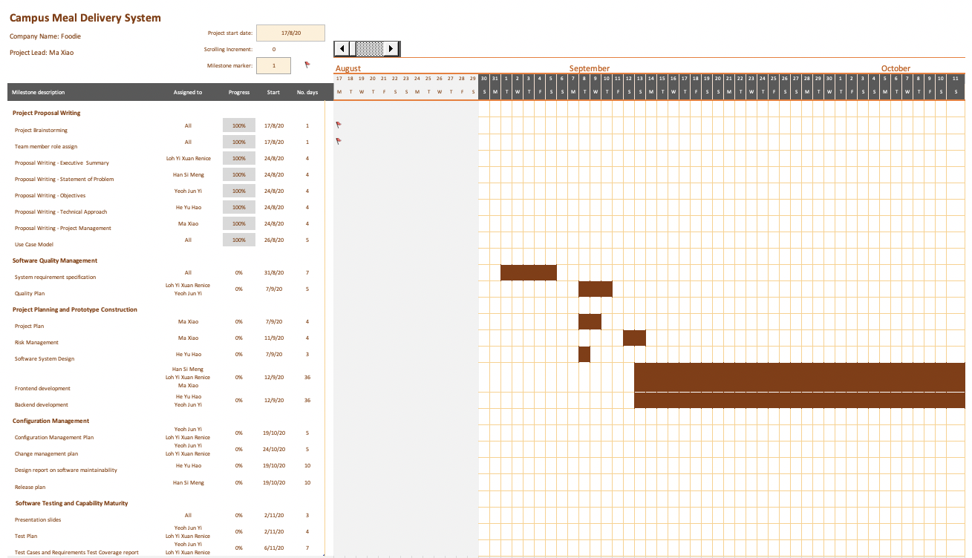 **Figure 1:** Gantt chart for the project

| **Task** | **Assign to** | **Start** | **Days** |
| --- | --- | --- | --- |
| **System requirement specification and Software Quality Management** | | | |
| System requirement specification | All | 31/8/20 | 7 |
| Quality Plan | Loh Yi Xuan Renice  Yeoh Jun Yi | 7/9/20 | 5 |
| **Project Planning and Prototype Construction** | | | |
| Project Plan | Ma Xiao | 7/9/20 | 4 |
| Risk Management | Ma Xiao | 11/9/20 | 4 |
| Software System Design | He Yu Hao | 7/9/20 | 3 |
| Frontend development | Han Si Meng  Loh Yi Xuan Renice  Ma Xiao | 12/9/20 | 36 |
| Backend development | He Yu Hao  Yeoh Jun Yi | 12/9/20 | 36 |
| **Configuration Management** | | | |
| Configuration Management Plan | Loh Yi Xuan Renice  Yeoh Jun Yi | 19/10/20 | 5 |
| Change management plan | Loh Yi Xuan Renice  Yeoh Jun Yi | 24/10/20 | 5 |
| Design report on software maintainability | He Yu Hao | 19/10/20 | 10 |
| Release plan | Han Si Meng | 19/10/20 | 10 |
| **Software Testing and Capability Maturity** | | | |
| Presentation slides | All | 2/11/20 | 3 |
| Test Plan | Loh Yi Xuan Renice  Yeoh Jun Yi | 2/11/20 | 4 |
| Test Cases and Requirements Test Coverage report | Loh Yi Xuan Renice  Yeoh Jun Yi | 6/11/20 | 7 |

**Table 1:** List of project tasks and plan

After completing these phases, the project team will provide the following deliverables.

**Deliverables**

**Budget**

To complete the project, the project team needs the following items.

Personnel: A professional team is necessary to complete a valuable project. We need a budget to pay project manager and project team members' salaries.

Equipment: A good computer will boost work efficiency and productivity, leading to a huge gain in developers’ activity. Apple’s MacBook Pro is the best choice for a developer's laptop recently. Each member in the team needs such a laptop.

Technologies: We need enterprise level software services to ensure scalability and security. As the most popular and widely used Backend-as-a-service (BaaS), Firebase is the top choice to implement this project’s backend. To release our product onto the Apple Store and Google Play Store, we need Apple Developer License and Google Developer License.

Utility costs: The project team to work together in a quiet and comfortable place with high-speed internet connection. Transportation fees for the team members and project managers are also needed.

Here is the project budget breakdown:

| **Category** | **Item** | **Supplier** | **Quantity** | **Unit Price** | **Total** |
| --- | --- | --- | --- | --- | --- |
| Personnel | Project manager | N.A. | 1 | $15,000.00 | **$15,000.00** |
| Project team members | 4 | $5,000.00 | **$20,000.00** |
| Equipment | Computers | Apple | 5 | $3,499.00 | **$17,495.00** |
| Technologies | Firebase Service | Google | 1 | $5,000.00 | **$5,000.00** |
| Android Developer Account | Google | 1 | $25.00 | **$25.00** |
| Apple Developer Account | Apple | 1 | $299.00 | **$299.00** |
| Utility costs | Office rental | NTU | 1 | $6,000.00 | **$6,000.00** |
| Transportation | Grab | 1 | $1,000.00 | **$1,000.00** |
| **TOTAL** | | | | | **$64,819.00** |

**Table 3:** Requested items and funds for initial design.

**Communication and Coordination with Sponsor**

Project manager is responsible for setting up the communication and coordinations with sponsors.

The communication will be done via online meetings on a weekly basis. Meetings will start on 17th Aug 2020 and will last for 10 weeks, which is the duration for the project.

In each meeting, sponsors will be presented with project progress and will be expecting to receive an email about the project progress. After each meeting, the project manager will gather the feedback from the sponsor and share the information with all the team members via email.

In each meeting, the project manager will report the project progress to the sponsor which consists of only information. The project manager may report project related requests to the sponsor, where the sponsor's response to the request is required.

**Team Qualifications**

Our team is formed by a group of top computer science major students from Nanyang Technological University (NTU). NTU is ranked No. 2 worldwide in terms of Computer Science. Each of the team members is well educated with computer science fundamental knowledge, professional software engineering knowledge and project management techniques. All of the project team members have experience in working on software development projects.

Below shows the qualification of each team member.

Han Simeng is a final year computer science student from NTU. She is passionate about research in Natural Language Processing and a member of the NTU-NLP Group writing papers to submit to top-tier international conferences. She is well-versed in several branches of NLP including text summarization and question answering. She also has experience in web and Android application development. She has completed several course software projects and won several NTU and NUS hackathons.

He Yuhao is a final year computer science student from NTU. He is interested in computer and math, and enjoys learning software development, and bringing in algorithm and machine learning techniques. He has experience in programming in Python, C, and Java, and has a good understanding about various software and system design models and principles. He has completed several projects in school and two internships on software engineering and machine learning.

Renice is a computer science major and is currently in her penultimate year of study. She boasts of in-depth knowledge in data science and has experience in software development. As an aficionado of data science, she is technically proficient and seeks to implement her analytical skills into practical ideas through the interplay of different niche disciplines. Besides her technical proficiency, she is also adept in project management skills and is experienced in allocating resources. She has also completed various projects in school and has participated in a number of coding competitions.

Ma Xiao is a final year computer science student from NTU. He is passionate about software engineering and proficient in many software development frameworks and technologies. He has experience in programming in C/C++, Python, Java and Javascript and he has knowledge about Amazon Web Service (AWS), MySQL and PostgreSQL, React and Django framework. He has finished 4 internships about software development in a local startup, a regional unicorn company and two big companies with global business.

Yeoh Jun Yi is a third year Computer Science major from NTU with a Diploma in Computer Engineering from Singapore Polytechnic. He is well versed in database/server administration and has a keen interest in all things security.

**References**

[1] Statista. 2020. *Singapore: Food-Delivery Spending COVID-19 Impact 2020 | Statista*. [online] Available at: <https://www.statista.com/statistics/1119998/singapore-food-delivery-services-spending-impact-covid-19/>.

[2] TAN, S. (2020). Coronavirus: More Singapore restaurant closures and layoffs to come, Chope survey finds. Retrieved 28 August 2020, from https://www.straitstimes.com/business/economy/coronavirus-more-singapore-restaurant-closures-and-layoffs-to-come-survey-finds

[3]WEI, T., 2020. *Food Delivery Sector Booms In A Time Of Coronavirus*. [online] The Straits Times. Available at: <https://www.straitstimes.com/singapore/transport/sector-booms-in-a-time-of-coronavirus>.

[4] Nea.gov.sg. 2020. *NEA Circuit Breaker Measures*. [online] Available at: <https://www.nea.gov.sg/our-services/public-cleanliness/environmental-cleaning-guidelines/post-circuit-breaker-measures> .

**Appendix A:**

**Résumés of Team Members**

